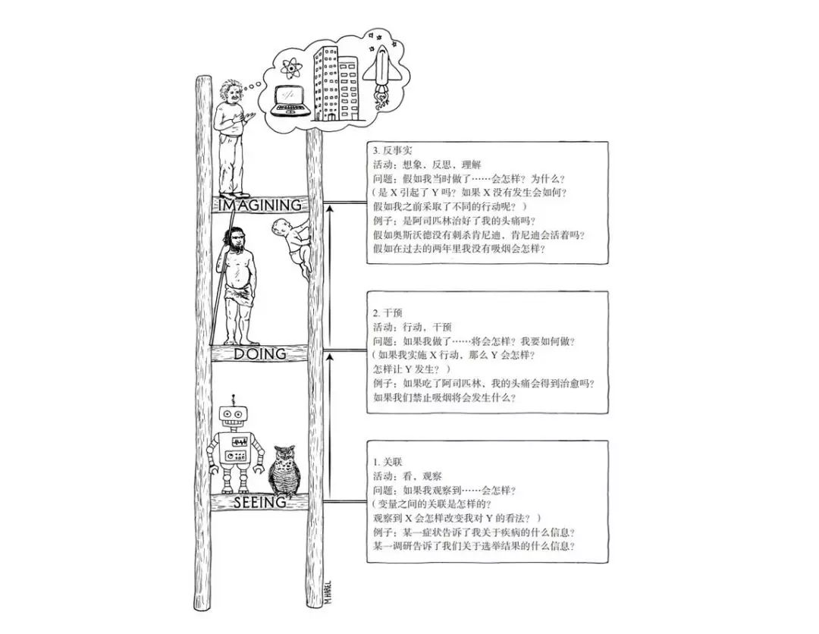

 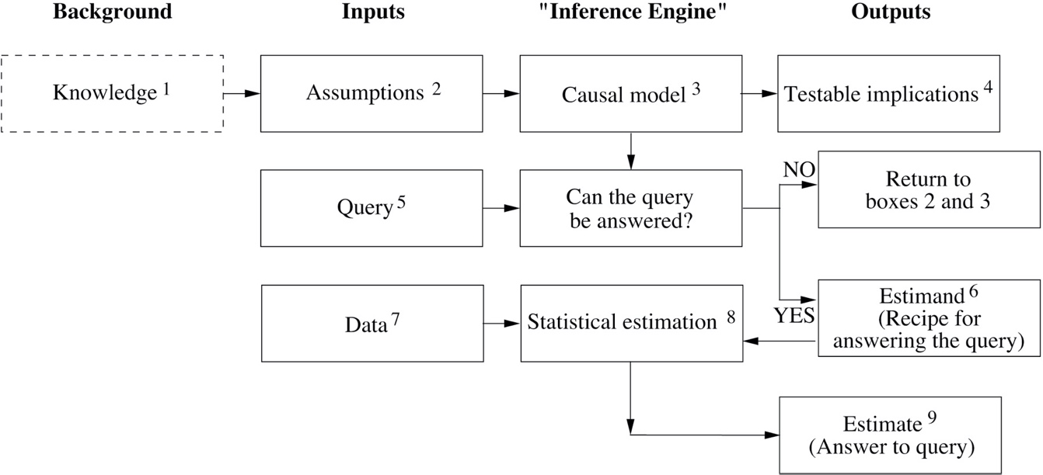

# Introduction

## Why Study Causation

## Simpson’s Paradox

# Preliminaries

## Structural Causal Models

### 2.1.1 g